LUNCHTIME & AFTERSCHOOL CLUBS
SUMMER
WEEKDAY | LUNCHTIME | TEACHER | AFTERSCHOOL | TEACHER
MONDAY |  |  | GYM CLUB  TENNIS CLUB - Juniors | RHONDA STOWE  LEE TILLYER
TUESDAY |  |  | ATHLETICS CLUB – Juniors  CONSTRUCTION CLUB – Yr 2  PLAY REHEARSAL – 5.00pm | MR TRENT  MRS WALKER  MISS WEBSTER
WEDNESDAY |  |  | OAA CLUB – Juniors  CONSTRUCTION CLUB – Juniors  PLAY REHEARSAL – 5.00pm  SCRIBE TRIBE | MRS MAYSEY /  MRS DAVIDSON  MISS SPENCER  MISS WEBSTER  MRS GRIFFITHS
THURSDAY | MCM  CHOIR  WEBSITE EDITORS – Yr 6 | MISS SPENCER  MRS CORBETT  MRS REED | CRICKET CLUB - Juniors  FRENCH CLUB – Yr 2 (4.00pm)  DANCE REHEARSAL – 4.30pm | MR TRENT  MRS TWEED  MRS CORBETT
FRIDAY |  |  |   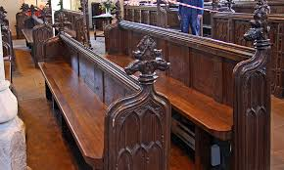  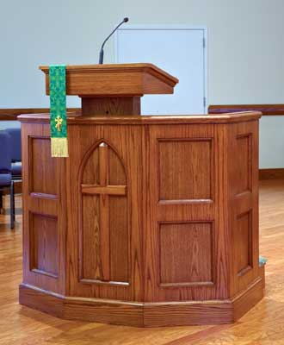  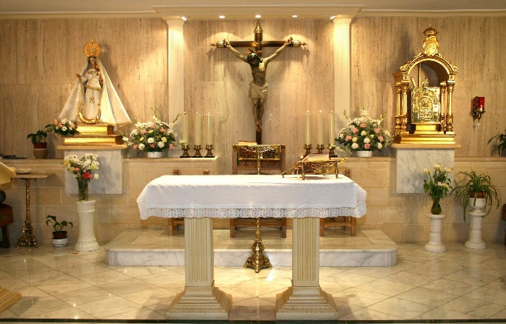  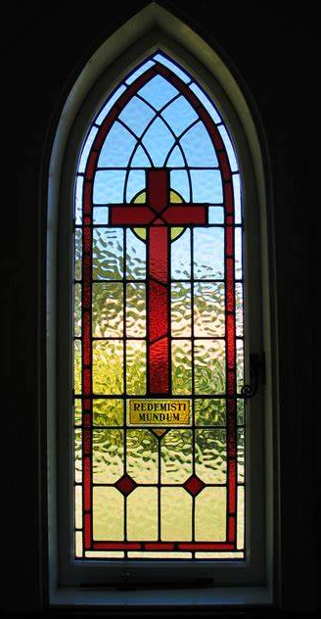    DANCE CLUB | JESS CORRELL

